**[Medicaid Divide: State-wise impact on the Diseases]**

**[Karan Ashok]**

**[University at Buffalo]**

* **Introduction:**

Our project **involves** gathering the Medicaid data from a different number of states. The data gathered will be on the basis of different classifications of diseases state-wise in the US. We will analyze it further to determine which state is better with respect to a particular disease. So that a person with particular ailment can refer to the analysis and decide to settle in that particular state. Also we analyzed the Medicaid and its data and how its prevalence and predominance in various states also depending on the various parameters such as age, gender, enrolment groups, etc. We have also put together a repository of some common diseases and graphically analyzed the trends of those diseases and various regions in United States.

* **How we came upon to work on this particular topic as our project:**

Medicaid is an important aspect of the US healthcare system, which provides health insurance to the lower-income group people. It is a government aided insurance scheme which is especially enforced for the betterment of women and children of low-income groups, children with special needs like the disabled as well as the elderly.

We decided to analyze this data available on Medicaid and differentiate it on the basis of various categories such as gender, age, race/ethnicity, enrolment groups, etc. This Research Paper consists of Medicare research mostly as it will help in understanding the trends in the spending by government in various US states as also the relationships between the spending and the various other factors as described by our research paper.

* **The Healthcare Facet of our project:**

The Healthcare aspect of our project is the various healthcare data that we have collaborated from various sources. As Medicaid program majorly affects the low-income group who cannot afford the private insurances plan, this state-wise trends provide a solid platform for people who require this aid. This analysis can help them know which state gets the most amount of grant and enrollees for Medicaid.

* **The Healthcare and Technology Coalesce in our project:**

Our research project has a perfect convergence of Healthcare and Technological components. Wherein the technological analysis of the healthcare data is performed using high grade data analysis tool named Tableau. In the later part of the research project this can be extended to a viewing app or a website where this graphical repository can be displayed.

* **Modus Operandi followed to go about with this project:**

We have come up with a comprehensive data repository to determine which state is performing better in providing the Medicaid coverage. We researched a lot from various research papers and collected data from government as well as other websites. We sorted the data, loaded it into excel and used these excels to load it on Tableau. We performed extensive research with the help of the data present online at various public and private websites and then using the **Tableau tool** for the analysis and visualization of the data repository we have come up with particular trends. The Analysis done on the Tableau platform was graphical and hence easy to interpret.

* **Contributions to the project:**

Karan and Shruti have researched and analyzed extensively the Medicare aspect of the project. While Jatin has concentrated on the state-wise split and prevalence and predominance of the diseases.

* **The following are some of the trends and analysis performed by us on tableau:**
* **Total Medicaid Spending:**

The Total spending on the Medicaid state-wise distribution for the fiscal year 2015 is represented below. The total Medicaid spending amounted to $552.0 billion in 2015.

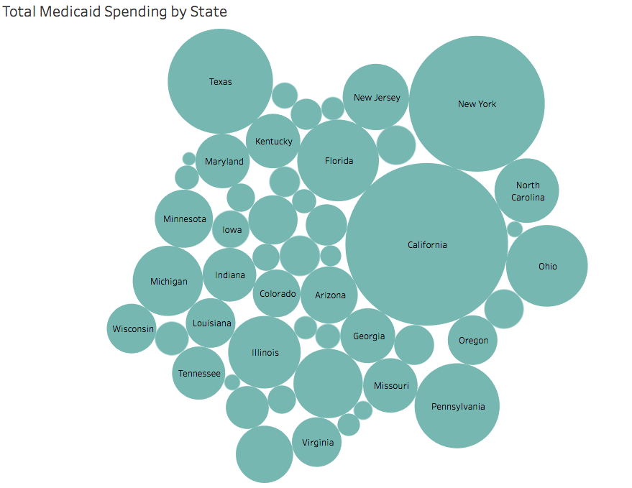

**By referring to the above figure, we can see that California, New York, Texas, Florida and Pennsylvania are among the biggest spenders on the Medicaid.**

* **Medicaid Spending by Enrolment group:**

The given data is for the fiscal year 2011. Enrolment groups has 4 categories: **Aged, Adult, Disabled and Children.** These include both federal as well state payments.

* **Aged**: People aged 65 and above.

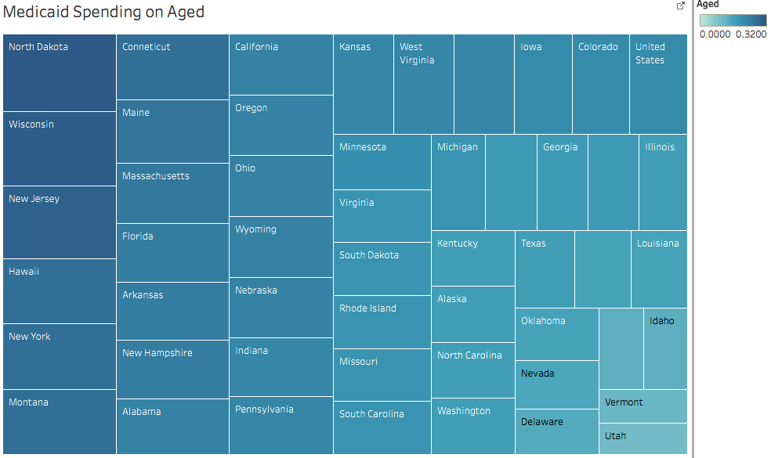

**States which experienced the largest growth in the Medicaid spending on Aged are North Dakota, Wisconsin, New Jersey, Hawaii, New York and Montana.**

* **Disabled**: People under the age of 65 and have a reported disability.

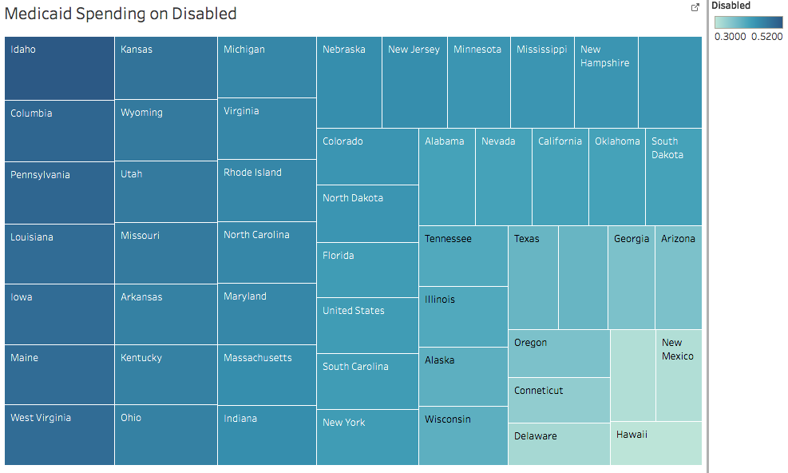

**States which experienced the largest growth in the Medicaid spending on disabled are Idaho, Columbia, Pennsylvania, Louisiana, Iowa and Maine.**

* **Adults**: Between the age of 19 to 64.

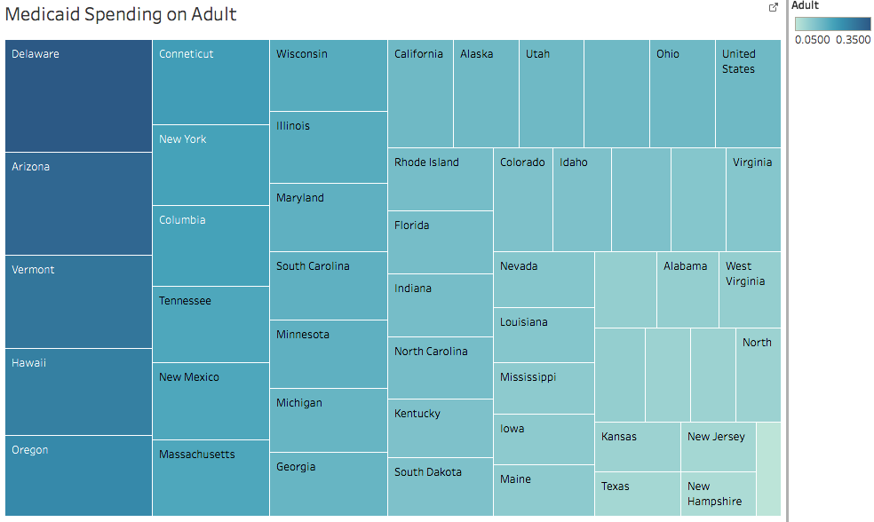

**States which experienced the largest growth in the Medicaid spending on Adult are Delaware, Arizona, Vermont, Hawaii and Oregon.**

This whole analysis is based on the percentage of people in each enrolment groups.

**Children**: People under the age of 18 years. In some states the eligibility is different on the basis of years.

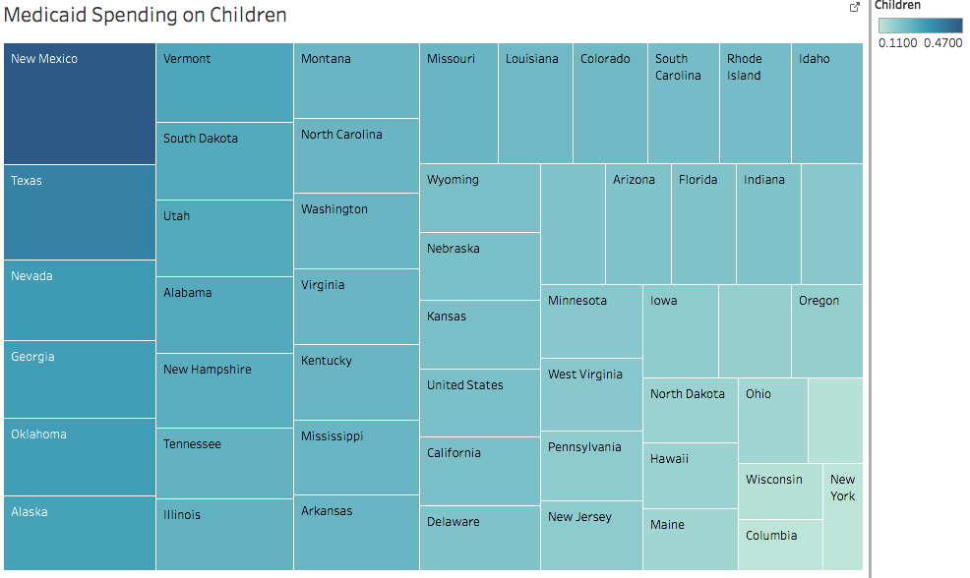

**States which experienced the largest growth in the Medicaid spending on Children are New Mexico, Texas, Nevada, Georgia, Oklahoma and Alaska.**

* **Medicaid Spending per Enrolee (Full or Partial benefit)**

This is the analysis of the spending per enrolee on the basis of USD per enrolee for both partial as well as full benefit enrolees.

Full benefit enrolees are those who have been enrolled for every month of the said particular time-period.

Partial benefit enrolees are enrolled for some time.

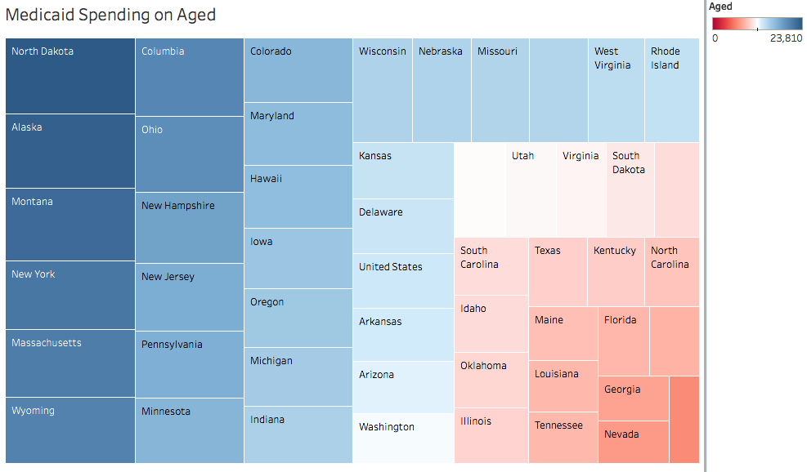

**States which are the biggest spenders in the Medicaid spending per Aged are North Dakota, Alaska, Montana, New York, Massachusetts and Wyoming.**

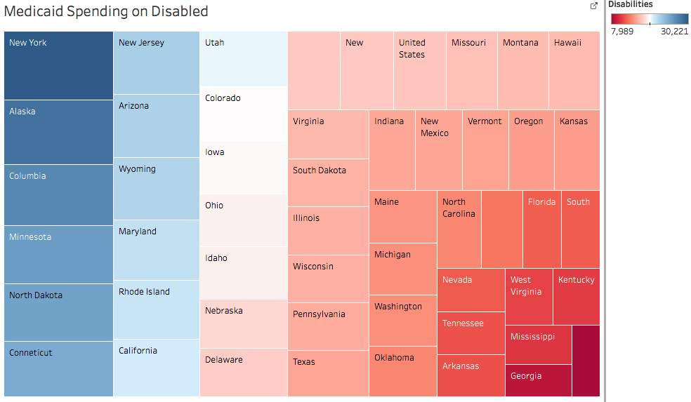

**States which are the biggest spenders in the Medicaid spending per disabled are New York, Alaska, Columbia, Minnesota, North Dakota and Connecticut.**

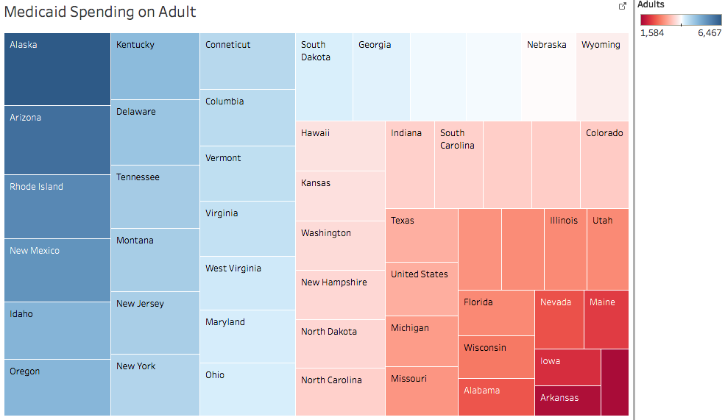

**States which are the biggest spenders in the Medicaid spending per Adult are Alaska, Arizona, Rhode Island, New Mexico, Idaho and Oregon.**

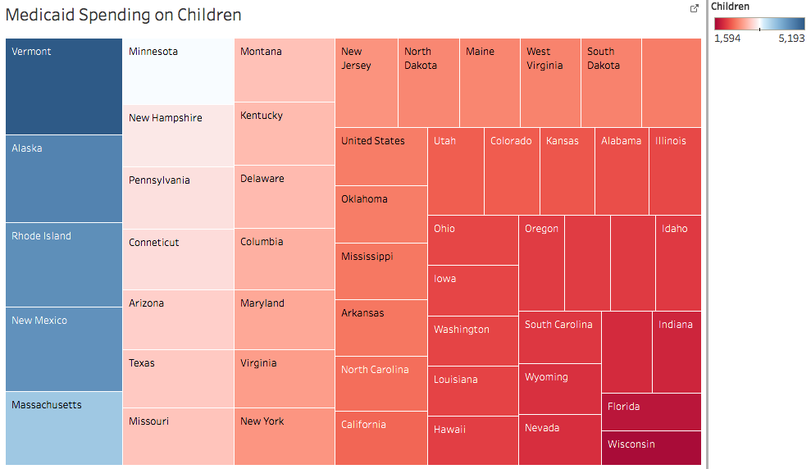

**States which are the biggest spenders in the Medicaid spending per Child are Vermont, Alaska, Rhode Island, New Mexico and Massachusetts.**

* **Average annual growth in Medicaid spending**

This analysis tells us about the annual growth in the Medicaid spending over the period of years.

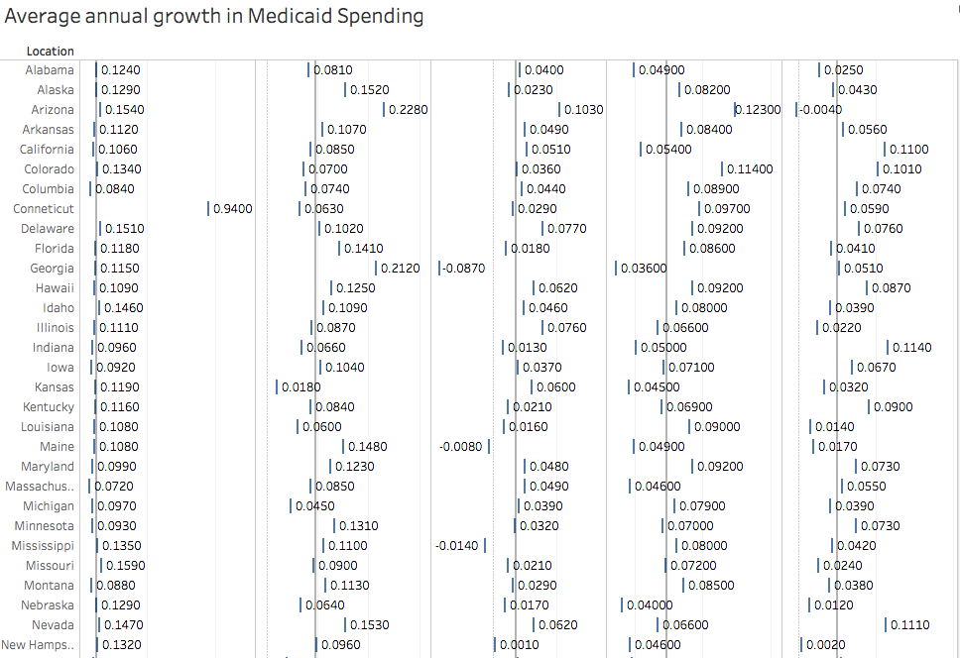

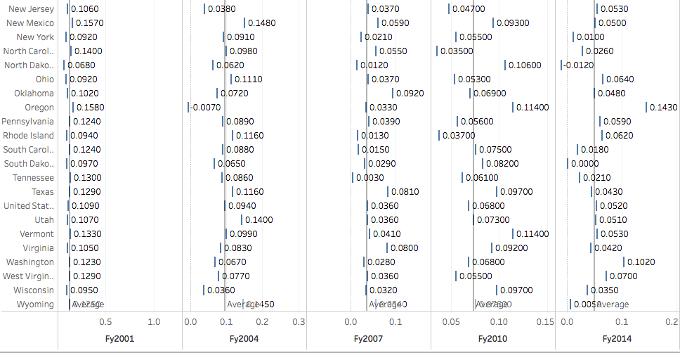

**By referring to above data, we can conclude:**

* **Connecticut is an outlier when it comes to the average annual growth in Medicaid spending for the FY 1990-2001.**
* **Oregon experienced negative growth for FY 2001-2004.**
* **Georgia, Maine and Mississippi experienced negative growth for FY 2004-2007.**
* **Arizona and North Dakota experienced negative growth for FY 2010-2014.**
* **Average Growth in Annual Medicaid Spending from FY2000 to FY2011 for Full-Benefit Enrolees**

Full benefit enrolees are the ones which have been enlisted for every month of the said period from FY2000 to FY2011 in the Medicaid program. So the below analysis is dependent on the average annual growth in the spending.

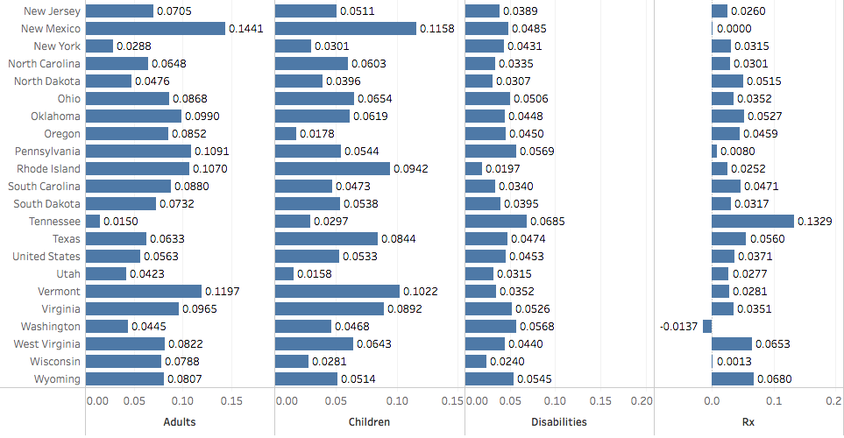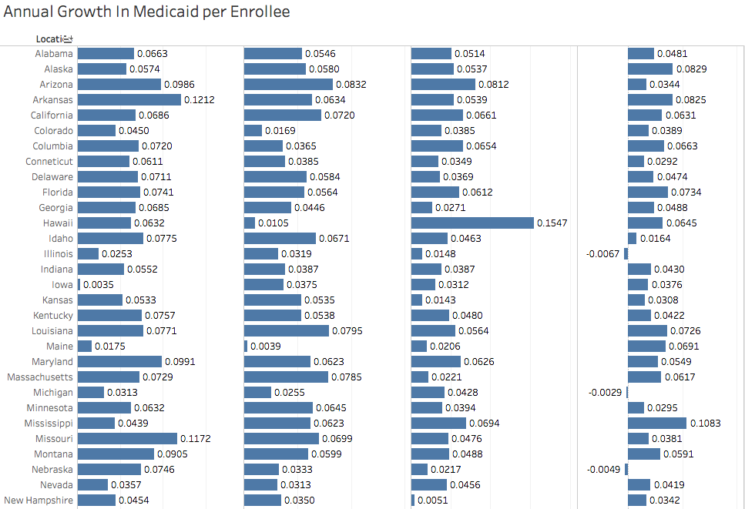

**Federal and State share of Medicaid spending**

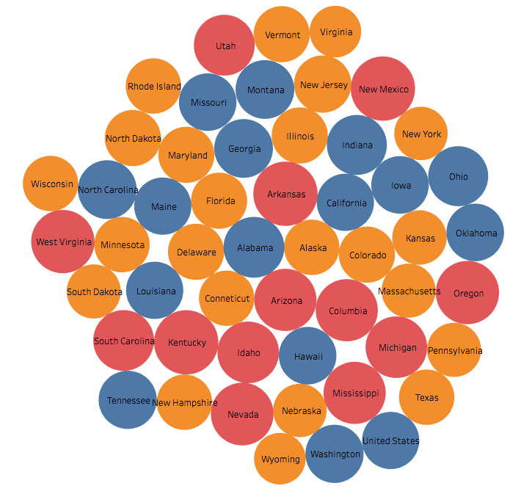

**Legends:**

Red – Federal share > 70%.

Blue – Federal share between 64% and 70%.

Yellow – Federal share < 64%.

* **Total Monthly Medicaid/CHIP Enrolment**

The monthly enrolment by percentage of people for Medicaid and CHIP for the period of July-September 2013.

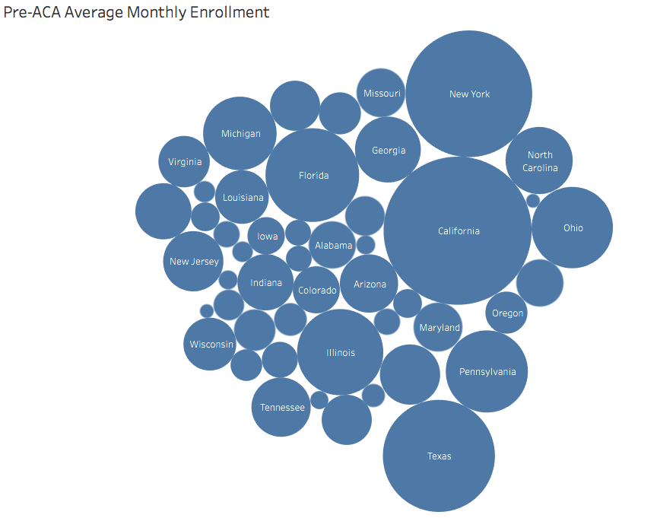

* **Monthly child enrolment in Medicaid and CHIP**

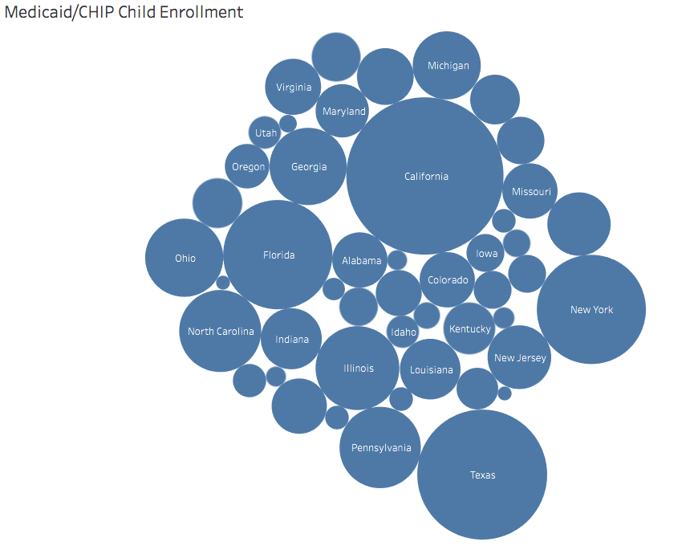

**By referring to the above data, we can conclude that California, Florida, Texas, New York and North Carolina are among the highest enrolees for child enrolment in Medicaid/CHIP program.**

* **Distribution of Medicaid Enrolees by enrolment group**

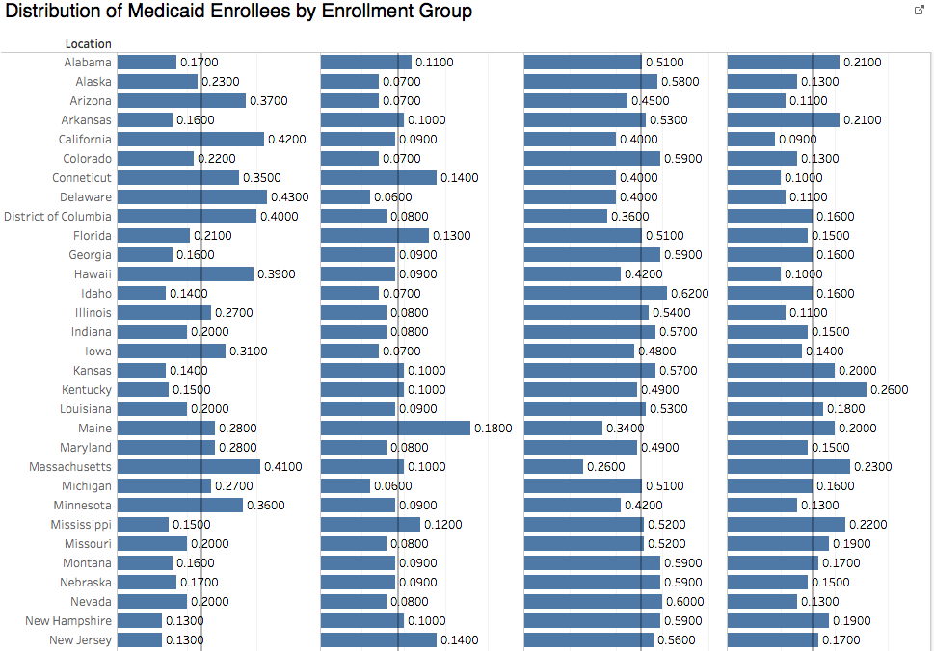

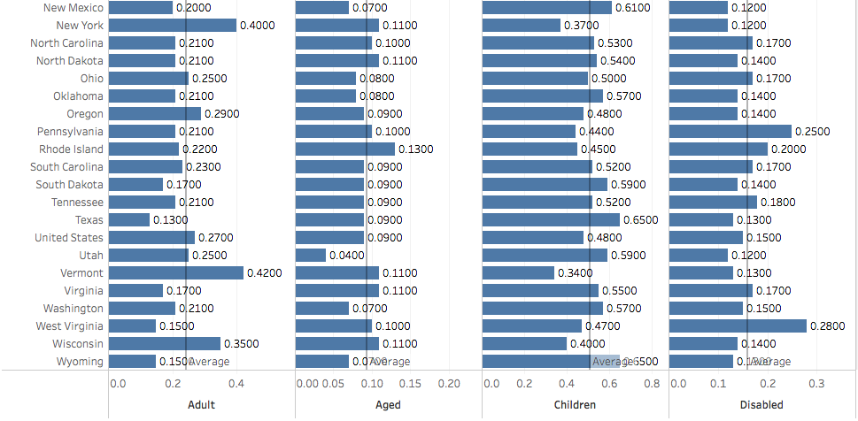

**By referring to the above figure we can conclude the below:**

* **Adults have an average Medicaid distribution of 22% over the whole country. States which have comparatively higher percentage distribution compared to the average are California, Delaware, Columbia, Massachusetts, New York and Vermont.**
* **Aged have an average Medicaid distribution of 10% over the whole country. States which have comparatively higher percentage distribution compared to the average are Connecticut, Maine, Florida, New Jersey and Rhode Island.**
* **Children have an average Medicaid distribution of 50% over the whole country. States which have comparatively higher percentage distribution compared to the average are Idaho, Nevada, New Mexico, Texas and Wyoming.**
* **Disabled have an average Medicaid distribution of 18% over the whole country. States which have comparatively higher percentage distribution compared to the average are Kentucky, Pennsylvania and West Virginia.**
* **Medicaid enrolment by gender**

The following data is for FY2011.

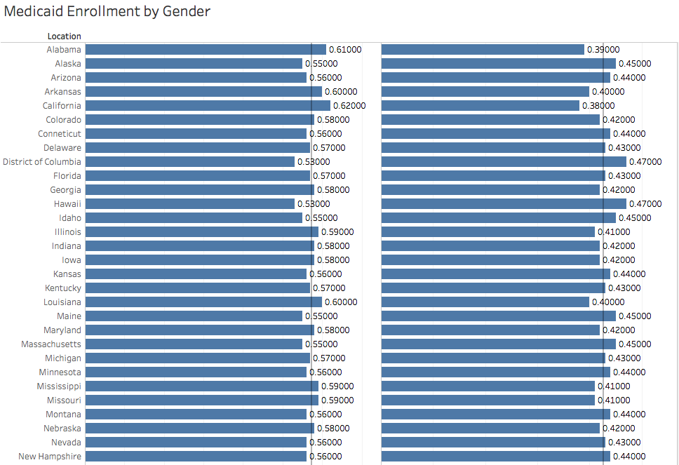

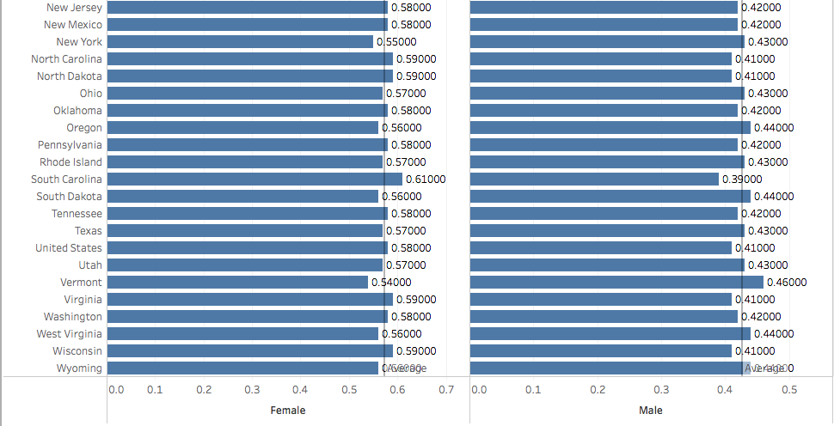

**By referring to the above figure we can conclude the below:**

* **Female have an average Medicaid distribution of 58% over the whole country.**
* **Male have an average Medicaid distribution of 42% over the whole country.**
* **Medicaid enrolment by Race/Ethnicity**

The following data is for FY2011.

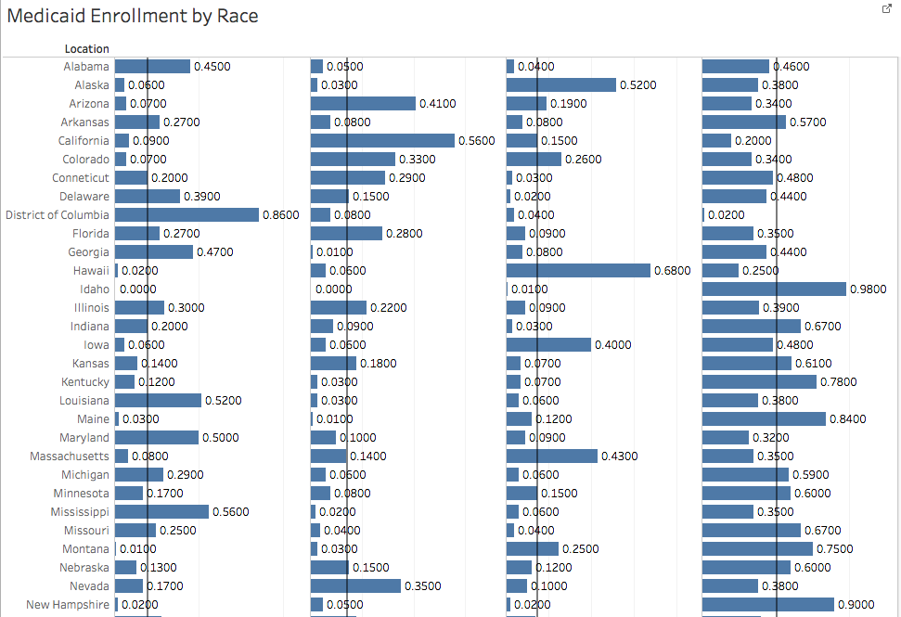

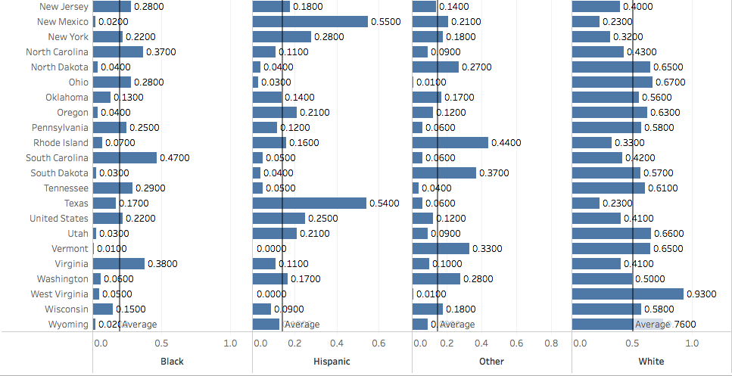

**By referring to the above figure we can conclude the below:**

* Blacks have an average Medicaid distribution of 18% over the whole country. States which have comparatively higher percentage distribution compared to the average are Alabama, Louisiana, Columbia, Maryland, Mississippi and South Carolina.
* Hispanic have an average Medicaid distribution of 16% over the whole country. States which have comparatively higher percentage distribution compared to the average are Arizona, California, Texas and New Mexico.
* Other have an average Medicaid distribution of 16% over the whole country. States which have comparatively higher percentage distribution compared to the average are Alaska, Hawaii, Massachusetts and Rhode Island.
* Whites have an average Medicaid distribution of 50% over the whole country. States which have comparatively higher percentage distribution compared to the average are Idaho, Maine, New Hampshire and West Virginia.
* **Medicaid enrolment by Age**

The following data is for FY2011.

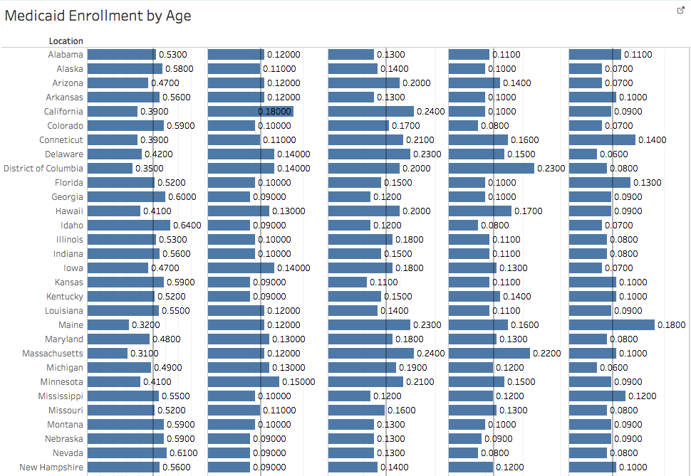

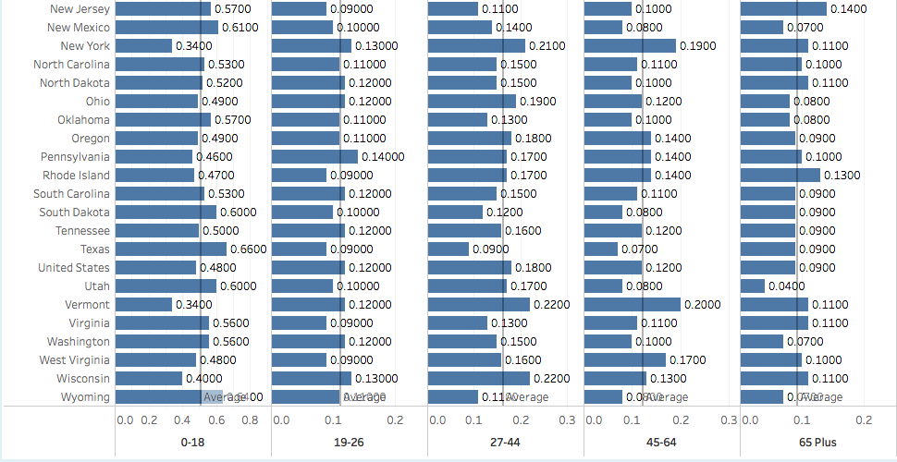

**By referring to the above figure we can conclude the below:**

* **0-18** have an average Medicaid distribution of 50% over the whole country. States which have comparatively higher percentage distribution compared to the average are Georgia, Idaho, Texas, Nevada, New Mexico and Wyoming.
* **19-26** have an average Medicaid distribution of 11% over the whole country. States which have comparatively higher percentage distribution compared to the average are California and Minnesota.
* **27-44** have an average Medicaid distribution of 18% over the whole country. States which have comparatively higher percentage distribution compared to the average are California and Massachusetts.
* **45-64** have an average Medicaid distribution of 12% over the whole country. States which have comparatively higher percentage distribution compared to the average are Columbia, Massachusetts, New York and Vermont.
* **65+** have an average Medicaid distribution of 9% over the whole country. States which have comparatively higher percentage distribution compared to the average are Connecticut, Maine and New Jersey.

**Prevalence of Diseases by Region**

In the below figure, we have visualised Cholera, Dengue, HIV, Hepatitis and Influenza per region.

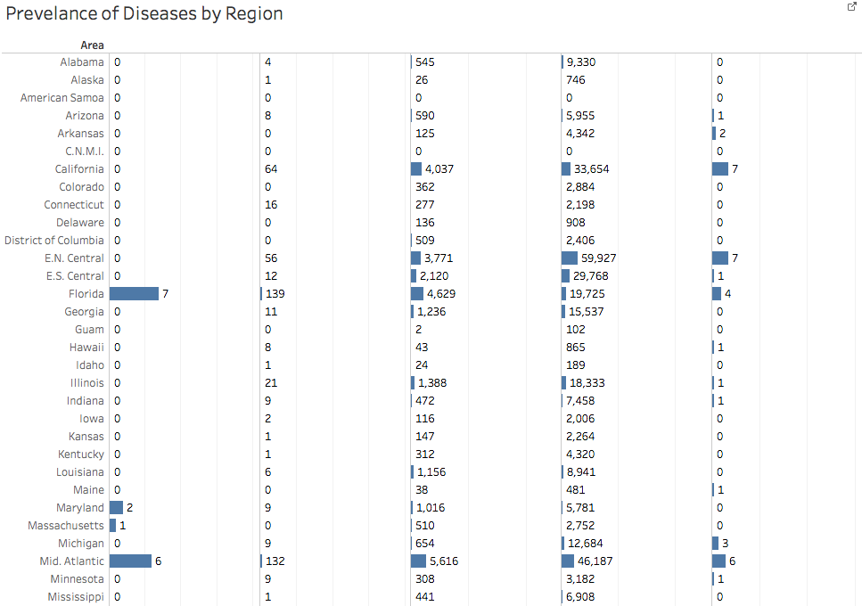

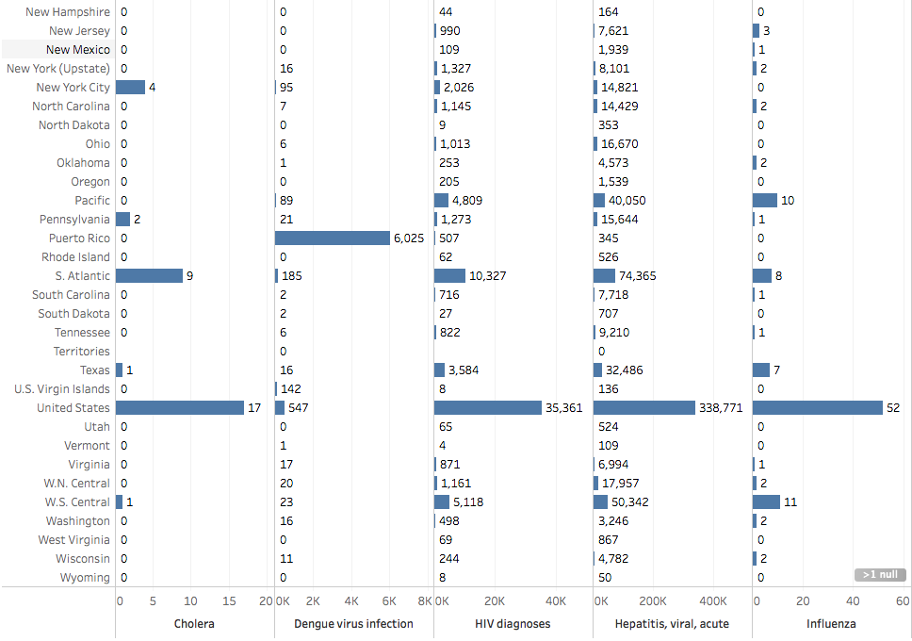

**In the below figure, we have visualised Malaria, Measles, Rabies, Tuberculosis and Typhoid per region.**

